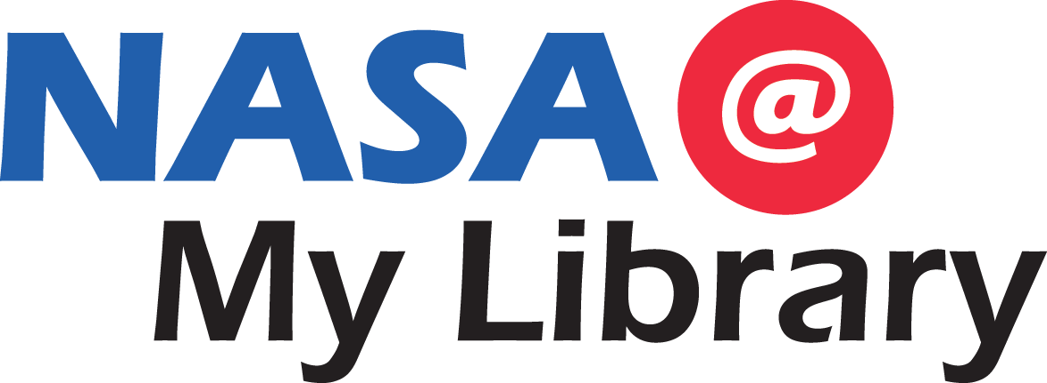

**Bringing Earth & Space Science to**

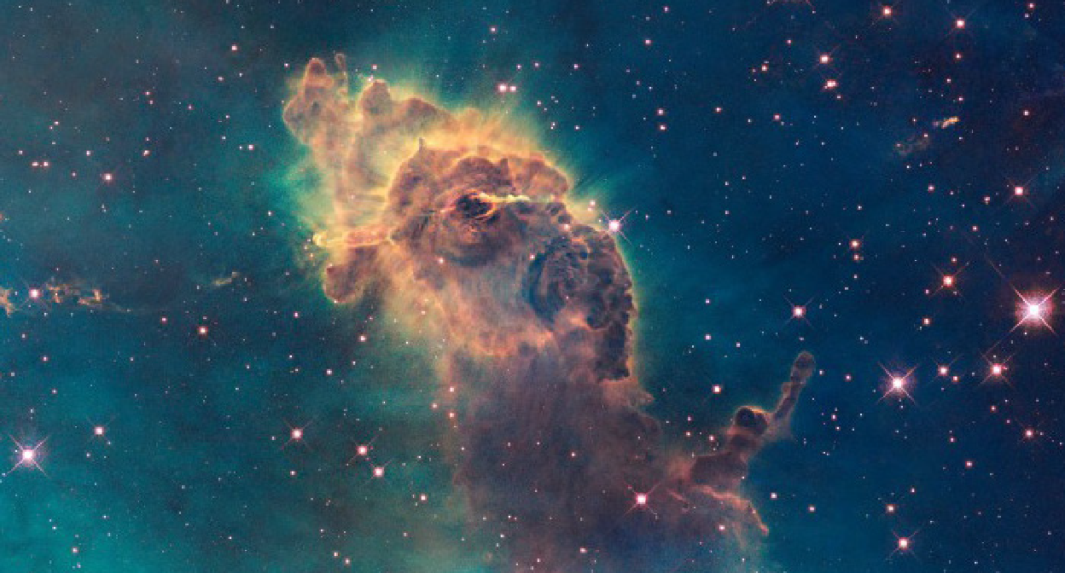***[Your library’s name]***

Photo Credit: NASA

***[Event name]***

***[Day, time, location]***

*[Insert event description, sample activity descriptions below]*

  

This project is brought to you by the Alabama Public Library Service and was made possible in part by the Institute of Museum and Library Services and STAR Net

*NASA@ My Library* is a national STAR Library Network (*STAR Net*) initiative that connects NASA, public libraries, state libraries, and their communities. Together we are working to increase STEM learning opportunities for millions of library patrons nationwide, particularly those underserved in STEM education.

**Kit #1: Sun-Earth-Moon Connections**

# Sample activity descriptions:

* Model both lunar and solar eclipses with easy-to-use tools
* Detect ultraviolet light in a creative way
* Use sorting cards to explore concepts relating to size, distance, and temperature
* Create a scale-size model of the Solar System
* Safely view the Sun with Sunoculars

# Sample photos:

Photo Credit: Space Science Institute/NCIL

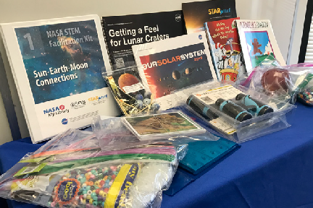

**Kit #2: Be a NASA Detective: Expanding Your Senses**

# Sample activity descriptions:

* Model the vast distances in our Solar System using a fun paper folding activity
* Create the shapes of the Moon’s phases with some “tasty” resources
* Explore art as science and science as art through planetary images
* Investigate the insides of planets using hands-on objects and detecting tools
* Use scientific tools such as a telescope and infrared thermometer to observe the properties of objects that are difficult to see with our eyes

# Sample photos

Photo Credit: Space Science Institute/NCIL

